CHAPTER FIVE

SUMMARY, CONCLUSION, AND RECOMMENDATION
5.1 Summary
This project focused on the design and implementation of a mobile-based Event Management System. The main goal was to create an efficient and user-friendly platform that simplifies the process of organizing, managing, and tracking events.
The system was developed using React Native for the frontend, FastAPI for the backend, and PostgreSQL for database management. Key features include secure user registration and authentication, event creation and tracking, task management, and real-time push notifications for event updates and reminders.
Through testing and evaluation, the system proved to be effective, reliable, and easy to use. It successfully addressed the limitations of the existing manual system by improving coordination, reducing errors, and enhancing communication between event organizers and participants.

5.2 Conclusion
The development of the mobile-based Event Management System has successfully achieved the objectives of this project. The system provides a secure and efficient platform for organizing and managing events, offering features such as user authentication, event creation, task tracking, and real-time notifications.
It enhances communication between organizers and participants, reduces manual effort, and minimizes errors commonly found in traditional event management methods. The system also ensures better coordination and accessibility through its mobile-friendly design.
Overall, the project demonstrates that a mobile-based solution can greatly improve event planning and management, making the process faster, more reliable, and more interactive.
5.3 Recommendation
Based on the system design, it is recommended that the implementation phase focus on developing a secure and user-friendly interface, following the designed workflows and interactions. Regular testing should be carried out to ensure the system performs well across different user scenarios, with particular attention to data security and access control.
Engaging stakeholders, including event organizers and participants, is advised to ensure the system meets practical needs. Future improvements could include adding advanced features, such as automated reminders, calendar integration, or mobile optimization, to enhance the overall user experience. Continuous evaluation and updates should be conducted to keep the system aligned with changing user requirements and technological advancements

REFERENCES
Adeola, O., & Ayeni, O. (2021). Mobile Event Management Systems: Enhancing user engagement and operational efficiency. Journal of Event Technology, 15(2), 45–58.
Adams, R., & Palmer, S. (2022). Mobile application development for emerging markets. International Journal of Software Engineering, 28(3), 112–126.
Afolayan, T., Bello, M., & Oladipo, A. (2023). Context-specific mobile solutions for event management in low-resource environments. African Journal of Information Systems, 12(1), 20–35.
Alhassan, I., Sammon, D., & Daly, M. (2021). User-centered design in digital platforms: Implications for adoption and usability. Journal of Information Technology, 36(4), 278–290.
Al-Kumaim, N., Al-Saadi, H., & Al-Jabri, M. (2021). Digital transformation in events management during COVID-19. International Journal of Event Management Research, 8(1), 15–29.
Alhawari, S., AlShihi, H., & AlHarthy, A. (2021). Digital workplace transformation and mobile applications. Journal of Enterprise Technology, 19(2), 65–78.
Buhalis, D., Leung, R., & Law, R. (2020). Real-time communication and analytics in event management. Tourism Management Perspectives, 34, 100646.
Das, S., & Pradhan, R. (2023). Comparative analysis of commercial event management systems. Journal of Event Management Studies, 10(1), 33–47.
Eze, S., & Omotayo, F. (2021). Cybersecurity frameworks in local event platforms in sub-Saharan Africa. International Journal of Cybersecurity Research, 6(3), 102–115.
Eze, S., Oke, O., & Akande, F. (2022). Accessibility and UX considerations for mobile applications in emerging economies. Journal of Mobile Computing, 14(2), 56–70.
Gupta, P., & Jain, S. (2021). React Native for cross-platform mobile applications: Best practices and performance analysis. International Journal of Mobile App Development, 7(2), 89–104.
Ibrahim, A., & Mohammed, K. (2024). Mobile EMS solutions for educational and corporate events. Journal of African Information Systems, 13(1), 44–60.
International Telecommunication Union (ITU). (2023). Measuring digital development: Facts and figures. Geneva: ITU Publications.
Kankanhalli, A., Tan, B., & Wei, K. (2021). Automation and efficiency in administrative processes. Information Systems Research, 32(1), 77–93.
Kwon, O., Bae, S., & Jeong, H. (2022). Event management during COVID-19: Lessons for hybrid events. Journal of Event Studies, 17(3), 120–136.
Leong, C., Tan, W., & Lim, J. (2020). User-centered design in mobile applications. Journal of Human-Computer Interaction, 36(5), 410–425.
Mensah, I., & Maiga, G. (2020). Mobile UX best practices for emerging markets. International Journal of Mobile Human-Computer Interaction, 12(4), 33–49.
Moroney, L. (2021). Firebase Cloud Messaging: Practical guide for mobile apps. Sebastopol, CA: O’Reilly Media.
Nigerian Communications Commission (NCC). (2022). Annual report on internet and mobile penetration in Nigeria. Abuja: NCC Publications.
Nnaji, I., & Ugwu, C. (2022). Localized mobile solutions for community event management. African Journal of Mobile Technologies, 9(2), 15–28.
Olanrewaju, T., Adeyemi, J., & Bello, S. (2022). Mobile applications in event planning: Trends and benefits. International Journal of Event Technology, 16(1), 40–52.
Okoye, P., & Chukwu, E. (2021). Technology adoption in educational events: Enhancing student engagement. Journal of Educational Technology, 18(3), 88–102.
Oluwaseun, A., Akinbinu, T., & Adetola, J. (2022). Challenges in event management: A case study of small institutions. Journal of Event Planning Research, 9(2), 21–34.
Rahman, S., & Khatun, F. (2021). Feedback collection mechanisms in digital event platforms. Journal of Information Management, 12(1), 55–68.
Sharma, R., & Rani, P. (2022). Communication challenges in hybrid events. International Journal of Event Coordination, 11(3), 70–85.
Singh, V., Mehta, S., & Kumar, R. (2021). Limitations of traditional event management practices. International Journal of Event Studies, 7(2), 12–28.
Statista. (2023). Number of smartphone users worldwide from 2016 to 2023. Retrieved from https://www.statista.com/statistics/330695/number-of-smartphone-users-worldwide/
Tiangolo, S. (2020). FastAPI: Modern, fast (high-performance), web framework for building APIs with Python. Retrieved from https://fastapi.tiangolo.com/
Ullah, I., Khan, S., & Ali, H. (2022). Mobile-first strategies for event management. Journal of Digital Innovation, 14(1), 33–47.
Zhou, Y., & Zhang, L. (2020). AI and gamification in event management systems. International Journal of Smart Technology, 8(4), 101–115.

APPENDIX A

SOURCE CODE
import logging
from fastapi import FastAPI, Request
from fastapi.middleware.cors import CORSMiddleware
from starlette.middleware.sessions import SessionMiddleware
from sqladmin import Admin, ModelView
from sqladmin.authentication import AuthenticationBackend
from database import engine, SessionLocal
from models import Base, User, Event
from auth import hash_password, verify_password
from config import settings
from routes import router

# Configure logging
logging.basicConfig(
level=logging.INFO if settings.is_production else logging.DEBUG,
format='%(asctime)s - %(name)s - %(levelname)s - %(message)s'
)
logger = logging.getLogger(__name__)

# Create tables
logger.info("Creating database tables...")
Base.metadata.create_all(bind=engine)
logger.info("Database tables created successfully")

app = FastAPI(
title="FastAPI Admin",
debug=settings.DEBUG
)

# Add CORS middleware
app.add_middleware(
CORSMiddleware,
allow_origins=settings.ALLOWED_ORIGINS,
allow_credentials=True,
allow_methods=["*"],
allow_headers=["*"],
)

# Add session middleware with secure settings
app.add_middleware(
SessionMiddleware,
secret_key=settings.SECRET_KEY,
max_age=settings.SESSION_MAX_AGE,
https_only=settings.is_production # Only send cookies over HTTPS in production
)

# Include API routes
app.include_router(router, prefix="/api")

class AdminAuth(AuthenticationBackend):
async def login(self, request: Request) -> bool:
form = await request.form()
username, password = form.get("username"), form.get("password")

if not username or not password:
logger.warning("Login attempt with missing credentials")
return False

db = SessionLocal()
try:
user = db.query(User).filter(User.username == username).first()

if not user:
logger.warning(f"Login attempt for non-existent user: {username}")
return False

if not user.is_active:
logger.warning(f"Login attempt for inactive user: {username}")
return False

password_valid = verify_password(password, user.hashed_password)

if not password_valid or not user.is_admin:
logger.warning(f"Failed login attempt for user: {username}")
return False

request.session.update({"user": username})
logger.info(f"Successful login for user: {username}")
return True
except Exception as e:
logger.error(f"Error during login: {str(e)}")
return False
finally:
db.close()

async def logout(self, request: Request) -> bool:
request.session.clear()
return True

async def authenticate(self, request: Request) -> bool:
user = request.session.get("user")
return bool(user)

class UserAdmin(ModelView, model=User):
column_list = [User.id, User.username, User.email, User.is_active, User.is_admin]
column_searchable_list = [User.username, User.email]
column_sortable_list = [User.id, User.username]

# Hide password in detail views
column_details_exclude_list = [User.hashed_password]

# Show hashed_password field in forms but with password widget
form_widget_args = {
"hashed_password": {
"type": "password"
}
}

form_args = {
"hashed_password": {
"label": "Password",
"description": "Enter the user's password (it will be hashed automatically)"
}
}

name = "User"
name_plural = "Users"
icon = "fa-solid fa-user"

async def on_model_change(self, data, model, is_created, request):
# Handle password hashing on create/update
if "hashed_password" in data and data["hashed_password"]:
password = data["hashed_password"]
# Only hash if it's not already hashed
# Bcrypt hashes are always 60 characters and start with $2
if len(password) != 60 or not password.startswith("$2"):
try:
data["hashed_password"] = hash_password(password)
logger.info(f"Password hashed for user: {data.get('username', 'unknown')}")
except Exception as e:
logger.error(f"Error hashing password: {str(e)}")
raise ValueError("Failed to hash password")
return data

async def on_model_delete(self, model, request):
"""Handle user deletion and cascade to related records"""
from models import Event, EventRegistration, EventFeedback

db = SessionLocal()
try:
user_id = model.id

# Delete related records
# Delete user's feedback
db.query(EventFeedback).filter(EventFeedback.user_id == user_id).delete()

# Delete user's event registrations
db.query(EventRegistration).filter(EventRegistration.user_id == user_id).delete()

# Delete or reassign events created by this user
# Option 1: Delete events (uncomment if you want to delete)
# db.query(Event).filter(Event.created_by == user_id).delete()

# Option 2: Set created_by to NULL or another admin (safer)
events = db.query(Event).filter(Event.created_by == user_id).all()
if events:
# Find first admin user to reassign events to
admin_user = db.query(User).filter(User.is_admin == True, User.id != user_id).first()
if admin_user:
for event in events:
event.created_by = admin_user.id
logger.info(f"Reassigned {len(events)} events from user {user_id} to admin {admin_user.id}")
else:
# No other admin, delete the events
db.query(Event).filter(Event.created_by == user_id).delete()
logger.warning(f"Deleted {len(events)} events - no admin to reassign to")

db.commit()
logger.info(f"Successfully deleted user {model.username} and related records")
except Exception as e:
db.rollback()
logger.error(f"Error deleting user: {str(e)}")
raise ValueError(f"Cannot delete user: {str(e)}")
finally:
db.close()

def is_accessible(self, request: Request) -> bool:
return request.session.get("user") is not None

class EventAdmin(ModelView, model=Event):
column_list = [Event.id, Event.title, Event.date, Event.location, Event.created_by, Event.created_at]
column_searchable_list = [Event.title, Event.location]
column_sortable_list = [Event.id, Event.title, Event.date, Event.created_at]
column_default_sort = (Event.created_at, True) # Sort by created_at descending

name = "Event"
name_plural = "Events"
icon = "fa-solid fa-calendar"

def is_accessible(self, request: Request) -> bool:
return request.session.get("user") is not None

# Create authentication backend and admin panel
authentication_backend = AdminAuth(secret_key=settings.SECRET_KEY)

admin = Admin(app, engine, authentication_backend=authentication_backend)
admin.add_view(UserAdmin)
admin.add_view(EventAdmin)

logger.info(f"Admin panel initialized in {settings.ENVIRONMENT} mode")

# auth.py
from passlib.context import CryptContext

pwd_context = CryptContext(schemes=["bcrypt"], deprecated="auto")

def hash_password(password: str) -> str:
return pwd_context.hash(password)

def verify_password(plain: str, hashed: str) -> bool:
return pwd_context.verify(plain, hashed)

from sqlalchemy import create_engine
from sqlalchemy.orm import sessionmaker
from config import settings

# Create engine with production-ready settings
engine = create_engine(
settings.DATABASE_URL,
pool_pre_ping=True, # Verify connections before use
pool_size=settings.DB_POOL_SIZE,
max_overflow=settings.DB_MAX_OVERFLOW,
echo=settings.DEBUG # Log SQL queries in debug mode
)

SessionLocal = sessionmaker(autocommit=False, autoflush=False, bind=engine)

# models.py
from sqlalchemy import Column, Integer, String, Boolean, Date, DateTime, ForeignKey, Text
from sqlalchemy.orm import declarative_base, relationship
from datetime import datetime

Base = declarative_base()

class User(Base):
__tablename__ = "users"

id = Column(Integer, primary_key=True)
first_name = Column(String(50), index=True, nullable=False)
last_name = Column(String(50), index=True, nullable=False)
email = Column(String(120), unique=True, nullable=False)
hashed_password = Column(String(255), nullable=False)
is_active = Column(Boolean, default=True)
is_admin = Column(Boolean, default=False)

class Event(Base):
__tablename__ = "events"

id = Column(Integer, primary_key=True, index=True)
title = Column(String, index=True, nullable=False)
description = Column(String, nullable=True)
date = Column(Date, nullable=False)
location = Column(String, nullable=True)
created_by = Column(Integer, nullable=False) # user_id of the creator
created_at = Column(DateTime, default=datetime.utcnow)
updated_at = Column(DateTime, default=datetime.utcnow, onupdate=datetime.utcnow)
view_count = Column(Integer, default=0)
attendee_count = Column(Integer, default=0)

class EventRegistration(Base):
__tablename__ = "event_registrations"

id = Column(Integer, primary_key=True, index=True)
event_id = Column(Integer, nullable=False)
user_id = Column(Integer, nullable=False)
registered_at = Column(DateTime, default=datetime.utcnow)
status = Column(String(20), default="registered") # registered, attended, cancelled
check_in_time = Column(DateTime, nullable=True)

class EventFeedback(Base):
__tablename__ = "event_feedback"

id = Column(Integer, primary_key=True, index=True)
event_id = Column(Integer, nullable=False)
user_id = Column(Integer, nullable=False)
rating = Column(Integer, nullable=False) # 1-5 stars
comment = Column(String, nullable=True)
created_at = Column(DateTime, default=datetime.utcnow)

class EventAnalytics(Base):
__tablename__ = "event_analytics"

id = Column(Integer, primary_key=True, index=True)
event_id = Column(Integer, nullable=False)
date = Column(Date, nullable=False)
views = Column(Integer, default=0)
registrations = Column(Integer, default=0)
attendees = Column(Integer, default=0)
shares = Column(Integer, default=0)

class EventStage(Base):
__tablename__ = "event_stages"

id = Column(Integer, primary_key=True, index=True)
name = Column(String(100), nullable=False) # e.g., Planning, Promotion, Execution, Post-Event
description = Column(Text, nullable=True)
order = Column(Integer, default=0) # For ordering stages
created_at = Column(DateTime, default=datetime.utcnow)

class EventTask(Base):
__tablename__ = "event_tasks"

id = Column(Integer, primary_key=True, index=True)
event_id = Column(Integer, ForeignKey("events.id"), nullable=False)
stage_id = Column(Integer, ForeignKey("event_stages.id"), nullable=True)
title = Column(String(200), nullable=False)
description = Column(Text, nullable=True)
is_completed = Column(Boolean, default=False)
priority = Column(String(20), default="medium") # low, medium, high
due_date = Column(Date, nullable=True)
assigned_to = Column(Integer, ForeignKey("users.id"), nullable=True)
created_by = Column(Integer, ForeignKey("users.id"), nullable=False)
created_at = Column(DateTime, default=datetime.utcnow)
completed_at = Column(DateTime, nullable=True)
updated_at = Column(DateTime, default=datetime.utcnow, onupdate=datetime.utcnow)

class Notification(Base):
__tablename__ = "notifications"

id = Column(Integer, primary_key=True, index=True)
user_id = Column(Integer, ForeignKey("users.id"), nullable=False)
event_id = Column(Integer, ForeignKey("events.id"), nullable=True)
title = Column(String(200), nullable=False)
message = Column(Text, nullable=False)
type = Column(String(50), nullable=False) # event_reminder, event_update, task_assigned, etc.
is_read = Column(Boolean, default=False)
sent_at = Column(DateTime, default=datetime.utcnow)
read_at = Column(DateTime, nullable=True)
data = Column(Text, nullable=True) # JSON data for additional info

class PushToken(Base):
__tablename__ = "push_tokens"

id = Column(Integer, primary_key=True, index=True)
user_id = Column(Integer, ForeignKey("users.id"), nullable=False)
token = Column(String(500), nullable=False, unique=True)
device_type = Column(String(20), nullable=False) # ios, android
created_at = Column(DateTime, default=datetime.utcnow)
updated_at = Column(DateTime, default=datetime.utcnow, onupdate=datetime.utcnow)
is_active = Column(Boolean, default=True)

class EventReminder(Base):
__tablename__ = "event_reminders"

id = Column(Integer, primary_key=True, index=True)
event_id = Column(Integer, ForeignKey("events.id"), nullable=False)
user_id = Column(Integer, ForeignKey("users.id"), nullable=False)
remind_at = Column(DateTime, nullable=False)
reminder_type = Column(String(50), nullable=False) # 1_day_before, 1_hour_before, etc.
is_sent = Column(Boolean, default=False)
sent_at = Column(DateTime, nullable=True)
created_at = Column(DateTime, default=datetime.utcnow)

# schemas.py
from pydantic import BaseModel, EmailStr
from typing import Optional
from datetime import date, datetime

class UserCreate(BaseModel):
username: str
email: EmailStr
password: str

class UserResponse(BaseModel):
id: int
username: str
email: str
is_active: bool
is_admin: bool

class Config:
from_attributes = True

class LoginRequest(BaseModel):
email: EmailStr
password: str

class EventCreate(BaseModel):
title: str
date: str
time: str
location: Optional[str] = None
description: Optional[str] = None
image_url: Optional[str] = None

class Event(BaseModel):
id: int
title: str
date: str
time: str
location: Optional[str] = None
description: Optional[str] = None
image_url: Optional[str] = None

class Config:
from_attributes = True

class User(BaseModel):
id: int
username: str

class Config:
from_attributes = True

class FeedbackBase(BaseModel):
rating: int
comment: Optional[str] = None

class FeedbackCreate(FeedbackBase):
event_id: int

class Feedback(FeedbackBase):
id: int
user_id: int
event_id: int
created_at: datetime
user: User

class Config:
from_attributes = True

APPENDIX B

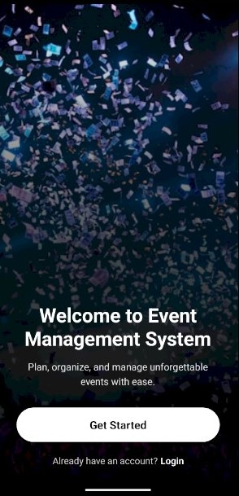

Figure51: IndexPage

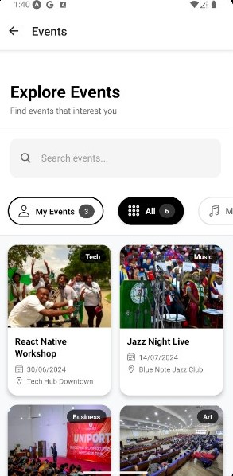

Figure 2: Event Menu

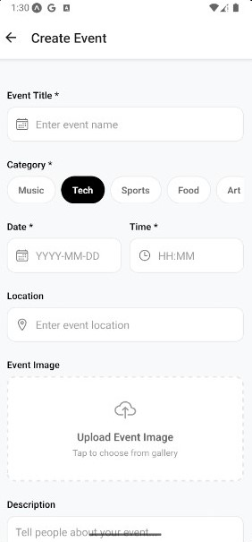

Figure 3: Create Event Form

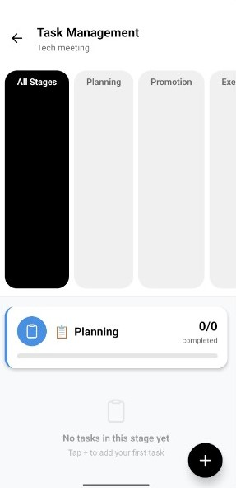

Figure 4: Task Management Page

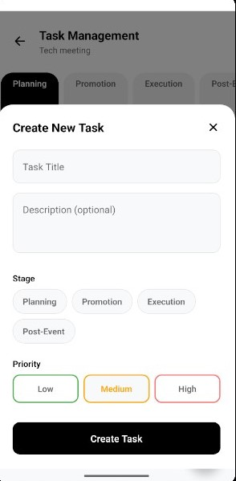

Figure 5: Create Task Form

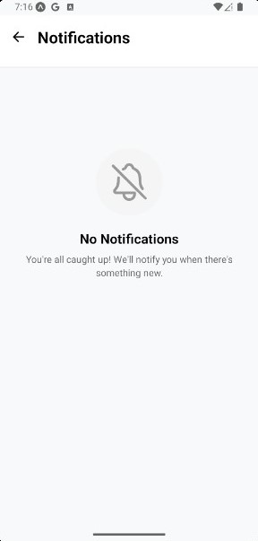

Figure 6: Notification Page

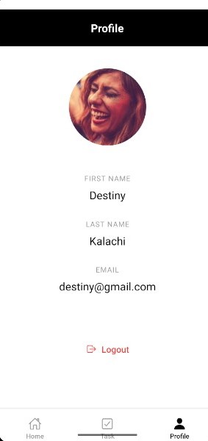

Figure 7: Profile Page

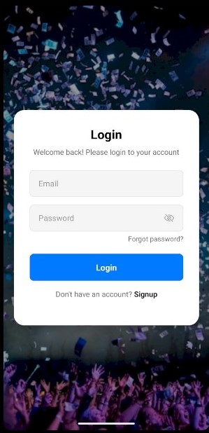
Figure 8: Login Form

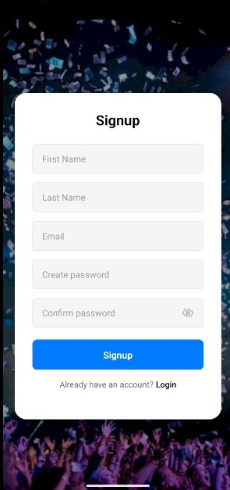
Figure 9: Registration Form

